**Audience Analysis Questionnaire/Interview**

Hi, everyone,

Your performance as persuasive speech maker involves three parts 1) audience analysis (20%)+ 2) Written Draft (40%)+ Oral delivery (40%). here comes the first task: Finish your audience analysis questionnaire/interview and submit the feedback worksheet.

Directions: Please read the two recommended essays (Attached file 3 &4)before you design your own audience questionnaire or interview. Your audience analysis questionnaire should first be circulated in your speech class before you submit it to reach a larger audience. It can be written either in English or Chinese (preferably English). After collecting your survey results, you are supposed to finish the following audience analysis feedback worksheet (Attached file 1) . A sample homework is presented (Attached file 2) for your reference.

irene wang

**Audience Analysis Questionnaire Feedback Worksheet**

* What is the specific purpose of my speech?

To persuade my audience to recognize the harm of objectification using ECNU GPA system as an example

* Who are the audience for my speech? (Demographic traits: age / gender /cultural background/preference…)

Full-time undergraduate students in ECNU.

The majority of them think they are in a society where people tend to see them as an object or a number instead of a human being.

* In choosing a specific purpose, how do **I narrow down the topic** so it will be appropriate to my audience?

Every student in ECNU is familiar with the based-on-ranking GPA system. Many students will check their GPA over and over again after the finals end. This is a common phenomenon in ECNU undergraduate student community. And the GPA system is secretly objectifying us in this way.

* Situational audience analysis:

1. What is the size of audience?

29 undergraduate students in ECNU finished the questionnaire.

1. What is their previous knowledge about the topic?

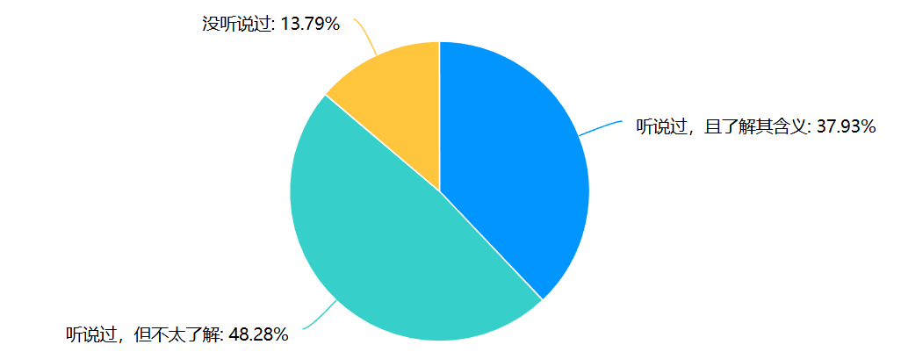

Most of them have heard the word “objectification”, but over 50% of students doesn’t know the meaning of the word.

3) What is their interest level in the topic?

I use the question “do you think that ‘objectification’ is a common problem in our daily life? ” to determine their interest level and the result is as follow:

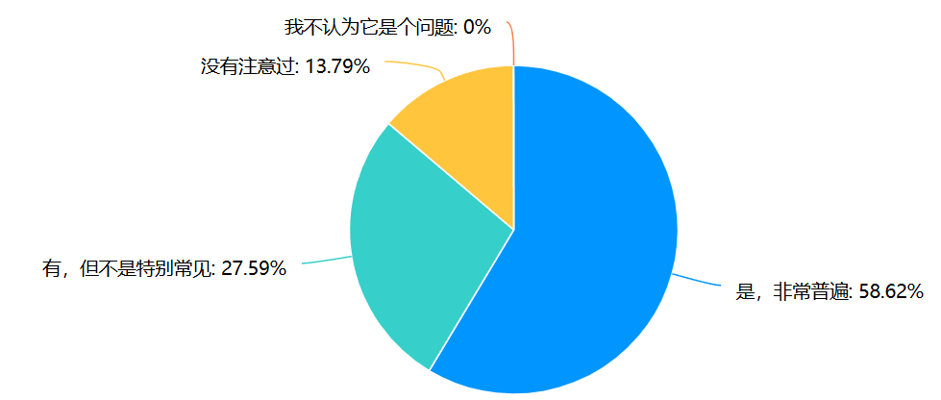

More than half of the participants reckon it as a common problem, but there are still some students who think it trivial or less common.

4) What is their original attitude toward the topic?

I use the question “do you think that we should be alert to ‘objectification’?” to determine their original attitude and the result is as follow:

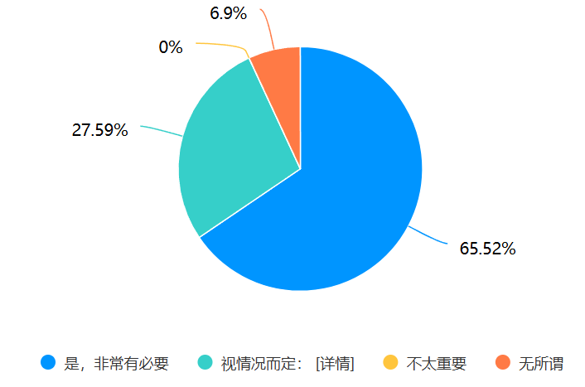

Most of them think it necessary. Some students give their own opinion on the question while a few students don’t care about it.

5) Other findings worthy of sharing/ out of my expectation?

Yup, I design my questionnaire in the following structure:

* First part, personal info collection
* Second part, let themselves rate the degree of their objectification
* Then, I ingeniously design several questions that put them into a common “moral dilemma” in ECNU and let them make their moves like a murder mystery game(剧本杀)
* After that, they are asked to rate the degree of their objectification again

The result is as follow:

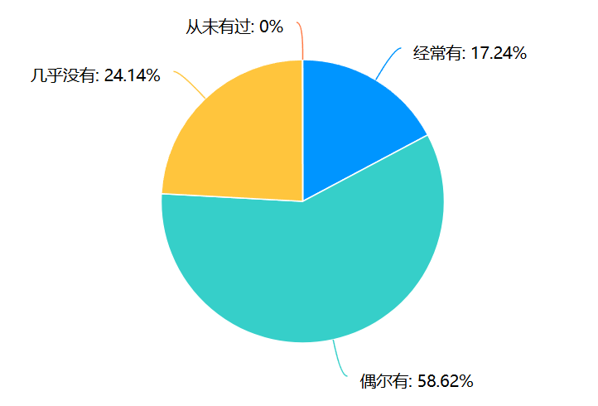 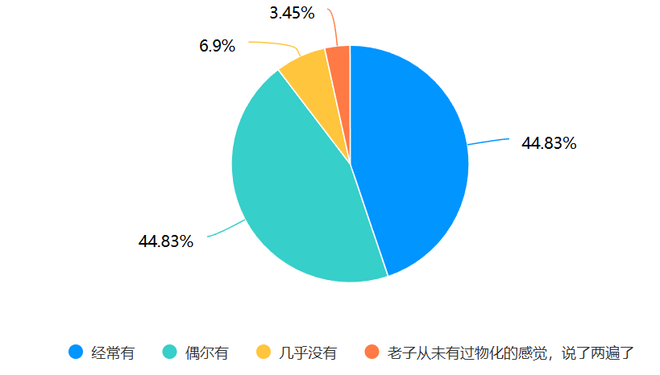

(The figure on the left displays the proportion of the degree of their objectification **before** they answer the situational questions, whereas the figure on the right shows the **after**)

a decent amount of students change their opinions after they answer the situational questions (over 15% of students who chose “almost no” decide to choose “occasionally” or “very often” after the questions and the percentage of option “very often” increased significantly) which implies that a lot of students are going through the process of objectification and they are not fully aware.

Another valuable finding would be two female answers. When they answered the question “do you think that we should be alert to ‘objectification’?”, they both chose the option “it depends” and give their specific reasons:



The first opinion (at the top) shows that her evaluation of harm isn’t so serious or urgent. Her statement has conflicts with herself. On the one hand, yes, the environment is hard to change, but does that mean “because I can’t improve the air quality by myself, I decided not to take any action.” You will wear a mask in a foggy Monday to protect your lungs from the bad weather. So in this situation, this participant **consciously abandons her personal subjectivity and surrender to the objectification.** On the other hand, her statement is the biggest victory of the objectification. She recognizes herself as an object or a number and this is called “self-objectification” (the highest level of objectification).

Another opinion points out the abuse of certain words in today’s society but it can’t cover the fact that we are the victim of the GPA system (the objectification). Also, the abuse of a word doesn’t devalue the word itself. We should have accurate analysis of particular problems to determine whether it is appropriate to use the word “objectification”.

I will refute these two views in my speech.

* **Adaptation to my audience**

1. What devices do you plan to use in the introduction to gain attention from your audience?

I will show a webpage screenshot of extremely high average GPA (every ECNUer is familiar with the webpage) which belongs to one of my friends. The average GPA is so high (nearly 4.0) that few people could reach it. Everyone will be astonished.

1. How would you relate your topic to your audience in the introduction?

I will tell them how my friend feels hollow even though he has such a high GPA (a striking contrast) and the reason behind the sense of hollowness is the objectification.

1. What are the possible main points of my speech? Why do I develop those points for my audience?

* Although most students recognize the harm of objectification, some of them still have misconception about the harm of objectification (like the two specific answers above) or think it trivial. I have to alter their belief.
* give some advice to protect us from the harm of objectification since over half of the participants recognize its severity.

Follow the logic, using GPA system as an example to illustrate the harm of objectification.

Then, explain why some misconceptions are wrong (also use GPA system as background)

At last, give some suggestions.

1. What decisions do I make in choosing supporting materials for my audience?

* Choose a living proof (my friend) as an example to illustrate the harm of objectification.
* Some expert’s testimony (paper findings or some arguments supported by hard data)
* My survey results (most of my participants have experienced it and think that we should be alert to objectification)